CALENDAR DATES AND REAL TIME NOTES

GOAL
- Have actual calendar date and time format for task notes
- The month format will be MM-DD-YYYY
- The time format will be HH:MM AM/PM
- Include an Error Popup if the user enters dates and times with incorrect syntax

MODULE
- We'll use Python's datetime module from the datetime library
- We'll also need to import messagebox from the Tkinter library

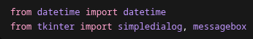

UPDATING THE SUBMIT( ) FUNCTION
- Right now, inside add_task_notes( ) and submit( ) we save the date and time as strings
- We'll collect both date and time entries with .get( ) and .strip( )
  - If the user chooses not to include a date or time, we'll set the values equal to an empty string ""
  - We have to use separate if-else blocks in case the user chooses to include a date or time for their task
  - If the date is filled out, we'll use a try-except block to .strptime( ) - strip parse time – the date in the format of %m-%d-%Y
  - If the time is filled out, we'll use a try-except block to .striptime( ) - strip parse time – the time in the format of %I:%M %p
    - We have to use try-except blocks because if the user input the date or time in the incorrect format, it will crash the program
    - This will cause a ValueError
    - We will also try to convert the datetime objects into ISO strings with .isoformat( )
      - This will allow us to save and load from JSON files
  - If there is a ValueError:
    - We'll use a messagebox.showerror( ) with the title and body:
      - Title = "Invalid Date or Time" – Specific to the if-else block
      - Message = Instructions on the correct date or time format
      - parent = the window of the add_task_notes( ) TopLevel widget popup
  - We must return if an error is thrown because we don't want to save data with the incorrect format

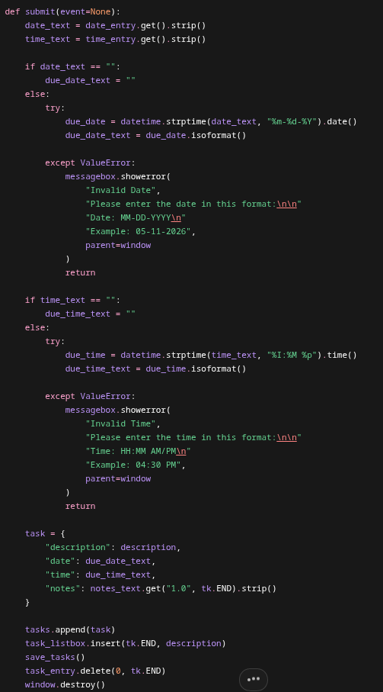

UPDATING OPEN_TASK_NOTES( )
- Because we changed the format of each task's date and time, we'll have to update how the open_task_notes( ) function functions to show this information to the user
- When choosing what to insert into the Entry widgets, we'll first get each tasks's date and time values from its dictionary
- We'll do a small check to see if it's an empty string
- If not:
  - We'll create a datetime object of the each value and insert the value into the Entry widget
    - We do this because we want to specify how each date and time value is shown to the user
    - Each date and time value is saved as an ISO Standard string
    - If we used the ISO Standard, the date would have year first
      - 2026-05-11
      - We want 05-11-2026

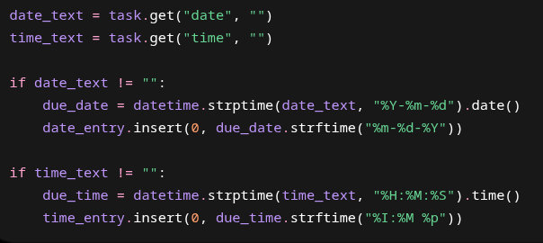

SAVING FROM OPEN_TASK_NOTES( )
- Because the user can also update this information from open_task_notes( ), we have to change how we save the task once it's updated
- We use the same code used in add_task_notes( )

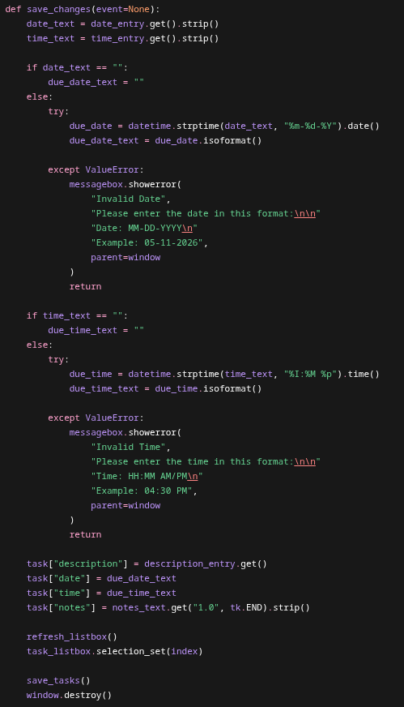

FULL CODE

import tkinter as tk
import json
import hashlib
import os
from datetime import datetime
from tkinter import simpledialog, messagebox
root = tk.Tk()
root.title("Task List")
root.geometry("500x450")
tasks = []
completed_tasks = 0
drag_start_index = None
TASKS_FILE = "tasks.json"
SALT_SIZE = 16
MASTER_PASSWORD = "generic_password"
def add_task_notes(description):
window = tk.Toplevel(root)
window.title("Task Details")
window.geometry("400x320")
window.transient(root)
window.grab_set()
window.focus_set()
tk.Label(window, text="Date:", font=("Arial", 12)).grid(row=0, column=0, sticky="e", padx=10, pady=8)
date_entry = tk.Entry(window, font=("Arial", 12))
date_entry.grid(row=0, column=1, padx=10, pady=8)
date_entry.focus_set()
tk.Label(window, text="Time:", font=("Arial", 12)).grid(row=1, column=0, sticky="e", padx=10, pady=8)
time_entry = tk.Entry(window, font=("Arial", 12))
time_entry.grid(row=1, column=1, padx=10, pady=8)
tk.Label(window, text="Notes:", font=("Arial", 12)).grid(row=2, column=0, sticky="ne", padx=10, pady=8)
notes_frame = tk.Frame(window)
notes_frame.grid(row=2, column=1, padx=10, pady=8)
notes_text = tk.Text(notes_frame, font=("Arial", 12), width=25, height=5)
notes_text.pack(side="left", fill="both", expand=True)
notes_scrollbar = tk.Scrollbar(notes_frame, command=notes_text.yview)
notes_scrollbar.pack(side="right", fill="y")
notes_text.config(yscrollcommand=notes_scrollbar.set)
def submit(event=None):
date_text = date_entry.get().strip()
time_text = time_entry.get().strip()
if date_text == "":
due_date_text = ""
else:
try:
due_date = datetime.strptime(date_text, "%m-%d-%Y").date()
due_date_text = due_date.isoformat()
except ValueError:
messagebox.showerror(
"Invalid Date",
"Please enter the date in this format:\n\n"
"Date: MM-DD-YYYY\n"
"Example: 05-11-2026",
parent=window
)
return
if time_text == "":
due_time_text = ""
else:
try:
due_time = datetime.strptime(time_text, "%I:%M %p").time()
due_time_text = due_time.isoformat()
except ValueError:
messagebox.showerror(
"Invalid Time",
"Please enter the time in this format:\n\n"
"Time: HH:MM AM/PM\n"
"Example: 04:30 PM",
parent=window
)
return
task = {
"description": description,
"date": due_date_text,
"time": due_time_text,
"notes": notes_text.get("1.0", tk.END).strip()
}
tasks.append(task)
task_listbox.insert(tk.END, description)
save_tasks()
task_entry.delete(0, tk.END)
window.destroy()
submit_button = tk.Button(window, text="Create Task", font=("Arial", 12), command=submit)
submit_button.grid(row=3, column=1, pady=15)
window.bind("<Return>", submit)
def add_task(event=None):
description = task_entry.get()
if description == "":
return
add_task_notes(description)
def create_key(password, salt):
password_bytes = password.encode()
combined = password_bytes + salt
key = hashlib.sha256(combined).digest()
return key
def delete_task(event=None):
selected = task_listbox.curselection()
if selected == ():
return
index = selected[0]
task_listbox.delete(index)
tasks.pop(index)
save_tasks()
def drag_task(event):
global drag_start_index
new_index = task_listbox.nearest(event.y)
if drag_start_index is None:
return
if new_index == drag_start_index:
return
task = tasks.pop(drag_start_index)
tasks.insert(new_index, task)
refresh_listbox()
task_listbox.selection_set(new_index)
drag_start_index = new_index
def load_encrypted_data(filename, password):
with open(filename, "rb") as file:
file_data = file.read()
salt = file_data[:SALT_SIZE]
encrypted_bytes = file_data[SALT_SIZE:]
key = create_key(password, salt)
decrypted_bytes = xor_data(encrypted_bytes, key)
json_text = decrypted_bytes.decode()
data = json.loads(json_text)
return data
def load_tasks():
global tasks
global completed_tasks
try:
data = load_encrypted_data(TASKS_FILE, MASTER_PASSWORD)
tasks = data.get("tasks", [])
completed_tasks = data.get("completed_tasks", 0)
for task in tasks:
task_listbox.insert(tk.END, task.get("description", ""))
except FileNotFoundError:
tasks = []
completed_tasks = 0
except UnicodeDecodeError:
tasks = []
completed_tasks = 0
print("Could not decrypt file. Wrong password or corrupted file.")
except json.JSONDecodeError:
tasks = []
completed_tasks = 0
print("Could not load JSON. Wrong password or corrupted file.")
def mark_completed():
global completed_tasks
selected = task_listbox.curselection()
if selected == ():
return
index = selected[0]
task_listbox.delete(index)
tasks.pop(index)
completed_tasks += 1
save_tasks()
update_counter()
def open_task_notes(event=None):
selected = task_listbox.curselection()
if selected == ():
return
index = selected[0]
task = tasks[index]
window = tk.Toplevel(root)
window.title("Edit Task Notes")
window.geometry("430x360")
window.transient(root)
window.wait_visibility()
window.focus_set()
window.grab_set()
tk.Label(window, text="Task:", font=("Arial", 12)).grid(
row=0, column=0, sticky="e", padx=10, pady=8
)
description_entry = tk.Entry(window, font=("Arial", 12), width=28)
description_entry.grid(row=0, column=1, padx=10, pady=8)
description_entry.insert(0, task.get("description", ""))
tk.Label(window, text="Date:", font=("Arial", 12)).grid(
row=1, column=0, sticky="e", padx=10, pady=8
)
date_entry = tk.Entry(window, font=("Arial", 12), width=28)
date_entry.grid(row=1, column=1, padx=10, pady=8)
tk.Label(window, text="Time:", font=("Arial", 12)).grid(
row=2, column=0, sticky="e", padx=10, pady=8
)
time_entry = tk.Entry(window, font=("Arial", 12), width=28)
time_entry.grid(row=2, column=1, padx=10, pady=8)
date_text = task.get("date", "")
time_text = task.get("time", "")
if date_text != "":
due_date = datetime.strptime(date_text, "%Y-%m-%d").date()
date_entry.insert(0, due_date.strftime("%m-%d-%Y"))
if time_text != "":
due_time = datetime.strptime(time_text, "%H:%M:%S").time()
time_entry.insert(0, due_time.strftime("%I:%M %p"))
tk.Label(window, text="Notes:", font=("Arial", 12)).grid(
row=3, column=0, sticky="ne", padx=10, pady=8
)
notes_frame = tk.Frame(window)
notes_frame.grid(row=3, column=1, padx=10, pady=8)
notes_text = tk.Text(notes_frame, font=("Arial", 12), width=25, height=6)
notes_text.pack(side="left", fill="both", expand=True)
notes_scrollbar = tk.Scrollbar(notes_frame, command=notes_text.yview)
notes_scrollbar.pack(side="right", fill="y")
notes_text.config(yscrollcommand=notes_scrollbar.set)
notes_text.insert("1.0", task.get("notes", ""))
def save_changes(event=None):
date_text = date_entry.get().strip()
time_text = time_entry.get().strip()
if date_text == "":
due_date_text = ""
else:
try:
due_date = datetime.strptime(date_text, "%m-%d-%Y").date()
due_date_text = due_date.isoformat()
except ValueError:
messagebox.showerror(
"Invalid Date",
"Please enter the date in this format:\n\n"
"Date: MM-DD-YYYY\n"
"Example: 05-11-2026",
parent=window
)
return
if time_text == "":
due_time_text = ""
else:
try:
due_time = datetime.strptime(time_text, "%I:%M %p").time()
due_time_text = due_time.isoformat()
except ValueError:
messagebox.showerror(
"Invalid Time",
"Please enter the time in this format:\n\n"
"Time: HH:MM AM/PM\n"
"Example: 04:30 PM",
parent=window
)
return
task["description"] = description_entry.get()
task["date"] = due_date_text
task["time"] = due_time_text
task["notes"] = notes_text.get("1.0", tk.END).strip()
refresh_listbox()
task_listbox.selection_set(index)
save_tasks()
window.destroy()
save_button = tk.Button(
window,
text="Save Changes",
font=("Arial", 12),
command=save_changes
)
save_button.grid(row=4, column=1, pady=15)
window.bind("<Return>", save_changes)
def refresh_listbox():
task_listbox.delete(0, tk.END)
for task in tasks:
task_listbox.insert(tk.END, task["description"])
def save_encrypted_data(data, filename, password):
json_text = json.dumps(data)
json_bytes = json_text.encode()
salt = os.urandom(SALT_SIZE)
key = create_key(password, salt)
encrypted_bytes = xor_data(json_bytes, key)
with open(filename, "wb") as file:
file.write(salt + encrypted_bytes)
def save_tasks():
data = {
"completed_tasks": completed_tasks,
"tasks": tasks
}
save_encrypted_data(data, TASKS_FILE, MASTER_PASSWORD)
def start_drag(event):
global drag_start_index
drag_start_index = task_listbox.nearest(event.y)
def stop_drag(event):
save_tasks()
def update_counter():
counter_label.config(text=f"Tasks Completed: {completed_tasks}")
def update_counter_manual():
global completed_tasks
new_total = simpledialog.askinteger(
"Update Completed Tasks",
"Enter the number you want the running total to be:",
parent=root
)
if new_total is None:
return
completed_tasks = new_total
save_tasks()
update_counter()
def xor_data(data, key):
result = bytearray()
for i in range(len(data)):
key_index = i % len(key)
new_byte = data[i] ^ key[key_index]
result.append(new_byte)
return bytes(result)
task_listbox = tk.Listbox(root, font=("Arial", 14), width=40, height=10)
task_listbox.pack(pady=10)
task_listbox.bind("<Button-1>", start_drag)
task_listbox.bind("<B1-Motion>", drag_task)
task_listbox.bind("<ButtonRelease-1>", stop_drag)
task_listbox.bind("<Double-Button-1>", open_task_notes)
load_tasks()
task_entry = tk.Entry(root, font=("Arial", 14))
task_entry.bind("<Return>", add_task)
task_entry.pack(pady=10)
task_entry.focus_set()
button_frame = tk.Frame(root)
button_frame.pack(pady=5, fill="x", padx=40)
delete_button = tk.Button(button_frame, text="Delete Task", font=("Arial", 12), command=delete_task)
delete_button.pack(side="left", padx=5)
add_button = tk.Button(button_frame, text="Add Task", font=("Arial", 12), command=add_task)
add_button.pack(side="left", padx=5)
mark_button = tk.Button(button_frame, text="Mark Completed", font=("Arial", 12), command=mark_completed)
mark_button.pack(side="left", padx=10)
counter_frame = tk.Frame(root)
counter_frame.pack(pady=10)
counter_label = tk.Label(counter_frame, text=f"Tasks Completed: {completed_tasks}", font=("Arial", 14))
counter_label.pack(side="left", padx=5)
update_counter_button = tk.Button(counter_frame, text="Update", font=("Arial", 12), command=update_counter_manual)
update_counter_button.pack(side="left", padx=5)
root.bind("d", delete_task)
root.mainloop()

